|  |
| --- |
| Luke Pepin Tragedy of the Commons MARN 1001E |

Question:

Do you agree or disagree with the assertion: Given human nature and the pressure of a growing population, "the tragedy of the commons" is inevitable?

Put another way Is it impossible for humans to manage commons effectively?

If you agree, you see “tragedy” as the inevitable consequence. If your argument includes scenarios where tragedy may be avoided, you must disagree with the premise. You might want to consider if approaches might work at one scale of society (or government) but not another (towns vs. countries).

The key is whether or not humans are able to solve this problem (Hardin’s tragedy).

Response:

The tragedy of the commons describes how self-interested individuals’ actions will eventually overuse and deplete shared resources. As a result, this leads to a long-term loss for all involved, humankind and the common resource (1). Negative assumptions about human nature run rampant in arguments about sustainability. Despite this fact, I disagree with the assertion that “the tragedy of the commons” is inevitable. The arc of history bends overwhelmingly towards the direction of innovation, stability, and support for greater and greater populations.

While Garrett Hardin’s argument is compelling, it is too critical about the essence of human nature. History provides numerous examples where communities have attempted to manage common resources through collective action and regulation. Two such examples are the Sustainable Fisheries Act of 1996 and its reaffirmation by Congress in 2006. Both directives were made by the U.S. Government, elected by its people, to seek a solution to such a critical need. While “A Future for U.S. Fisheries” displays some of the failures of these laws, they do show collective action and regulation from one of the most powerful governments in the world to seek a solution (2). Hardin operates on the assumption that everyone seeks to expand their use of the commons, while plenty work towards and within sustainable guidelines, and society around them is negative towards those who don’t. Below is a screenshot from Google Books Ngram Viewer displaying the growth of the word “sustainability” in literature over the last 100 years:

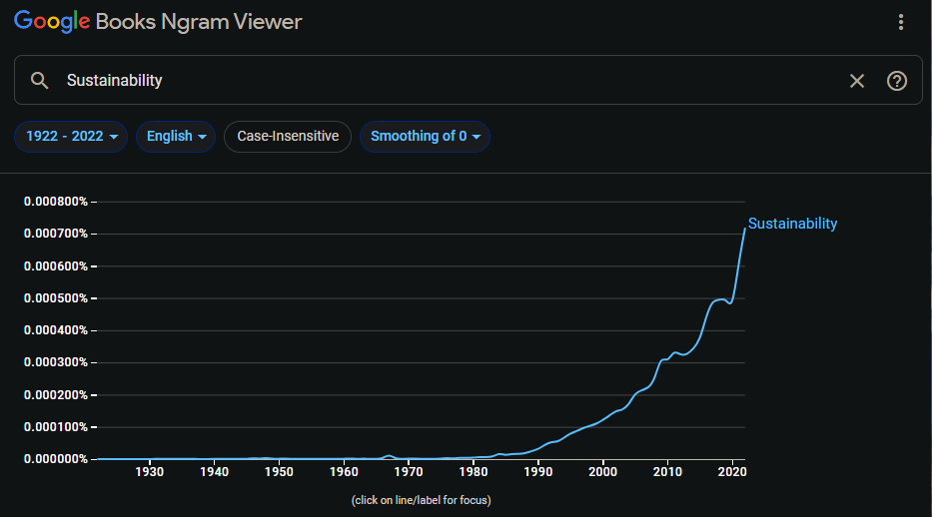

Technological advancements and innovative practices play a crucial role in mitigating the tragedy of the commons. For example, advancements in sustainable agriculture and renewable energy have shown that it is possible to meet human needs without depleting resources. Innovations such as precision farming, which optimizes resource use, and the development of alternative energy sources, reduce the strain on common resources (3). Additionally, advancements in data technology allow for an ever-increasing improvement in most people’s perception of the world, enabling better decision-making and resource management. Historically, it is once again shown through cooperation and innovation that humans have gone to the moon and back; their capabilities to solve problems are much more effective than their capacity to create them. For instance, the development of solar and wind energy technologies has significantly reduced reliance on fossil fuels, demonstrating how innovation can lead to sustainable resource management.

Effective management of commons also requires recognizing that human nature is inherently geared towards supporting larger populations. Throughout history, humans have developed complex social structures and institutions to ensure the survival and growth of their communities. This drive to support greater population sizes has led to the creation of stable institutions and supportive policies that manage resources effectively. For instance, the establishment of marine protected areas has been successful in preserving fish stocks and marine biodiversity, ensuring food security for growing populations (4). Additionally, international agreements like the Paris Agreement on climate change illustrate how global cooperation can address common challenges. These agreements show that when nations come together with a common goal, significant progress can be made in managing shared resources sustainably, reflecting humanity’s innate tendency to innovate and collaborate for the greater good.

In conclusion, while the tragedy of the commons presents a significant challenge, it is not an inevitable outcome. Through innovation, effective governance, and collective action, humans have the capacity to manage common resources sustainably. The key lies in recognizing the importance of cooperation and the implementation of policies that promote long-term sustainability over short-term gains. By fostering a culture of responsibility and stewardship, it is possible to avoid the dire consequences predicted by Hardin and ensure that common resources are preserved for future generations.

Citations:

[1] Hardin, G. 1968. The Tragedy of the Commons. Science, 162(3859), 1243-1248. DOI: 10.1126/science.162.3859.1243.

[2] Safina, C. 2009. A future for U.S. fisheries. Issues in Science and Technology 25: 43-46

[3] Caddy, J. F., and J. C. Seijo. 2005. This is more difficult than we thought! The responsibility of scientists, managers and stakeholders to mitigate the unsustainability of marine fisheries. Philosophical Transactions of the Royal Society B: Biological Sciences 360: 59-75.

[4] Pauly, D. 2009. Beyond duplicity and ignorance in global fisheries. Scientia Marina 73: 215-224.